Circuit Documentation
Summary
This circuit involves a Seeeduino XIAO microcontroller interfacing with an MCP23S17 I/O expander, two resistors, and two green LEDs. The circuit is designed to control the LEDs using the I/O expander, which communicates with the microcontroller via SPI. The Seeeduino XIAO provides power and control signals to the MCP23S17, which in turn drives the LEDs through current-limiting resistors.

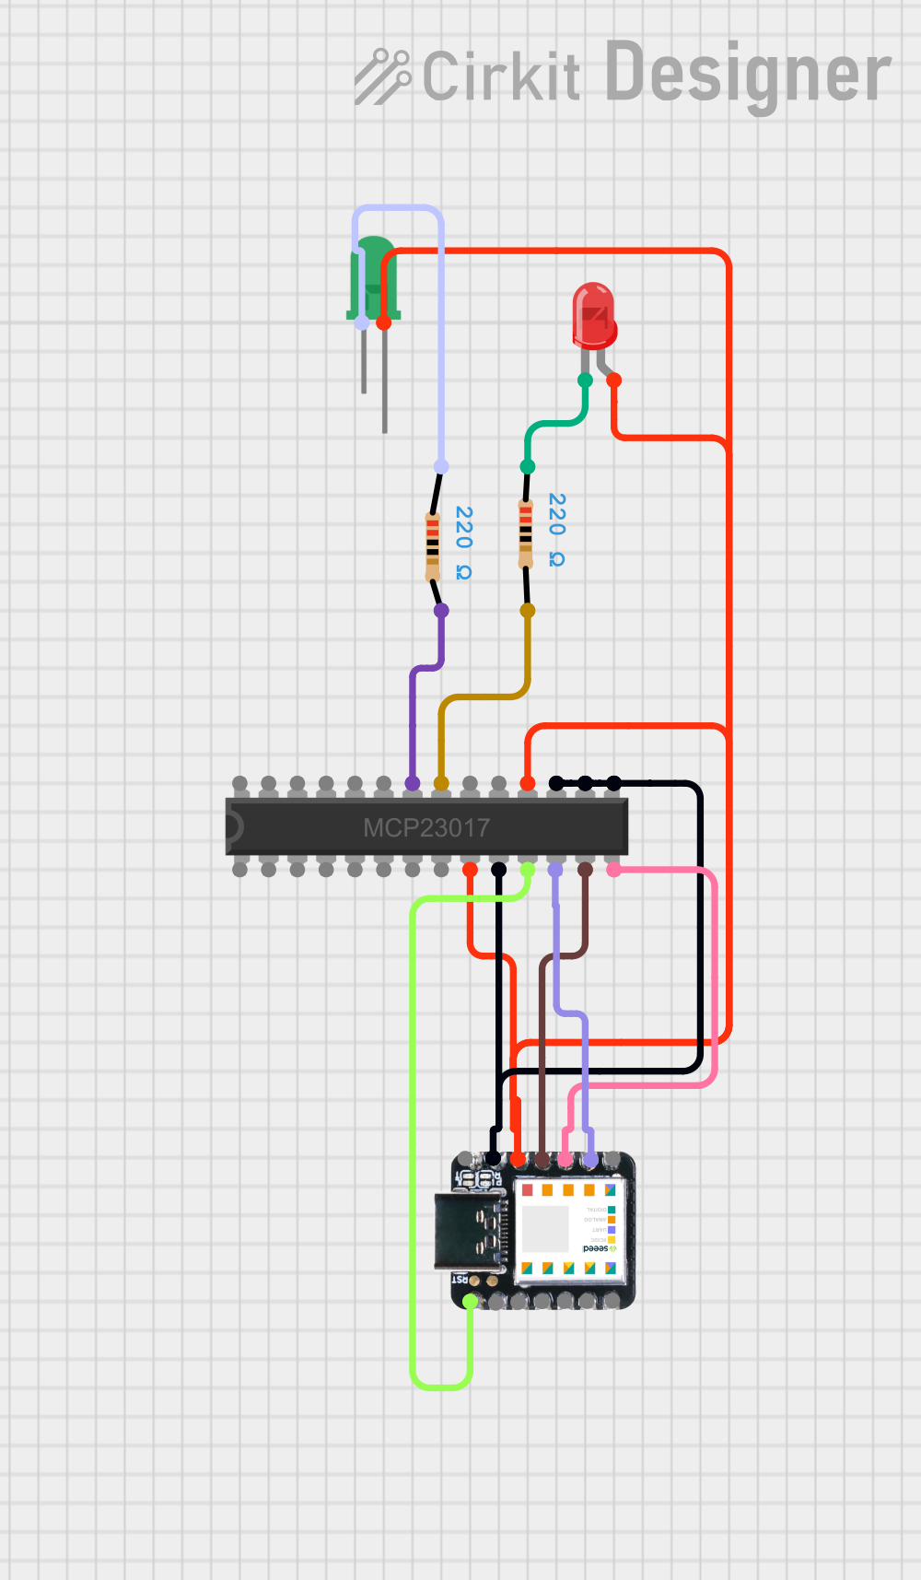
Component List
- Seeeduino XIAO
- Description: A compact microcontroller board based on the SAMD21 microcontroller.
- Pins: A0 - D0 - DAC, A1 - D1, A2 - D2, A3 - D3, A4 - D4 - SDA, A5 - D5 - SCL, A6 - D6 - TX, 5V, GND, 3V3, A10 - D10 - MOSI, A9 - D9 - MISO, A8 - D8 - SCK, A7 - D7 - RX
- Resistor (220 Ohms)
- Description: A passive electrical component that limits current flow.
- Pins: pin1, pin2
- Properties: Resistance: 220 Ohms
- Green LED
- Description: A light-emitting diode that emits green light.
- Pins: +, -
- LED: Two Pin (green) - Long Pins
- Description: A green LED with long pins for easy breadboard use.
- Pins: cathode, anode
- MCP23S17
- Description: A 16-bit I/O expander with SPI interface.
- Pins: GPB0, GPB1, GPB2, GPB3, GPB4, GPB5, GPB6, GPB7, A1, A0, SO, SI, CS, VSS, VDD, INTA, INTB, RESET, A2, GPA1, GPA0, GPA5, GPA4, GPA3, GPA2, GPA7, GPA6, SCK
Wiring Details
Seeeduino XIAO
- GND is connected to the VSS pin of the MCP23S17.
- 3V3 is connected to the VDD and RESET pins of the MCP23S17, and the anode of the Green LED.
- A10 - D10 - MOSI is connected to the SI pin of the MCP23S17.
- A9 - D9 - MISO is connected to the SO pin of the MCP23S17.
- A8 - D8 - SCK is connected to the SCK pin of the MCP23S17.
- A0 - D0 - DAC is connected to the CS pin of the MCP23S17.
Resistor (220 Ohms)
- First Resistor:
- pin1 is connected to the cathode of the LED: Two Pin (green) - Long Pins.
- pin2 is connected to the GPA0 pin of the MCP23S17.
- Second Resistor:
- pin1 is connected to the negative pin of the Green LED.
- pin2 is connected to the GPA1 pin of the MCP23S17.
Green LED
- + is connected to the 3V3 pin of the Seeeduino XIAO.
- - is connected to pin1 of the second resistor.
LED: Two Pin (green) - Long Pins
- anode is connected to the 3V3 pin of the Seeeduino XIAO.
- cathode is connected to pin1 of the first resistor.
MCP23S17
- VSS is connected to the GND pin of the Seeeduino XIAO.
- VDD and RESET are connected to the 3V3 pin of the Seeeduino XIAO.
- SI is connected to the A10 - D10 - MOSI pin of the Seeeduino XIAO.
- SO is connected to the A9 - D9 - MISO pin of the Seeeduino XIAO.
- SCK is connected to the A8 - D8 - SCK pin of the Seeeduino XIAO.
- CS is connected to the A0 - D0 - DAC pin of the Seeeduino XIAO.
- GPA0 is connected to pin2 of the first resistor.
- GPA1 is connected to pin2 of the second resistor.
Code Documentation
There is no code provided for this circuit. The microcontroller code would typically handle the SPI communication with the MCP23S17 to control the state of the LEDs.

